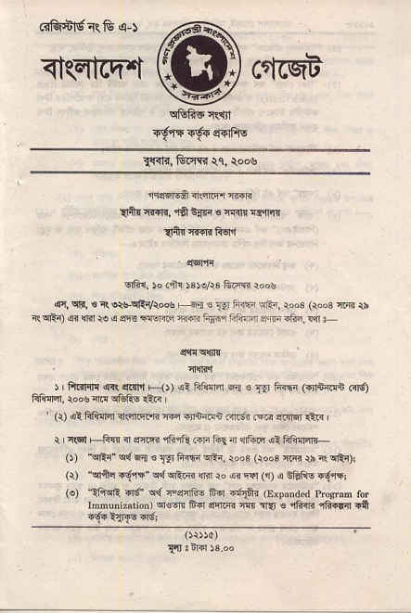
<t(qfcq.t ^{ctlrqb} ffi (aG*tgR&q-s
_{T{{lir,} G.Iir tr, \oos
nr46|EA i..qrzPr 8{rtr
_{a+rnT{i{,} ^{,rii$irr} _{ts} q{{lnrfiq.{
_{dftr} rd{r{ fiEr'l
, qEFli
^{qfrn.} ," dt{ sre/r3 Grm ioos
!fc, cF. s _{R} quqRv\o@ ^{|j1 !} _{lij inin} ^{qr!{.} rod (qoo3 ffi \b (qlt{) ar {ff _{to} ^{q} sE ffi ffi FTir fnirira $(*i .Gi, !a +
4!icl,F
i, _{ft'lr]I} ^{qr(} dctn H), tF!:F 6aof f,.F (drnrrn @itl trllr.n. {oa rlF rElF dti I
' (r) .e! FAffi n.irF.'r< ffi .,lnfld .irtr .r.r $.r]q l?n
I r!F| +Ff{ rl _{e-F} ^{qfr"&} ffi fiE rr 1lf€q al Fn{4+- _{O)} ^{.qrii} q{ ^{q;n €} _{T{r li@} ^{qtr,} roo3 (roo3 iri? rs _{i\} qrttj _{(r)} ^{"qnq{S{ qd qftR} lin ro _{ar} ^{q€l} _{(i)} ^{q} i&Fs +6jffj _{(e)} ^{_1fffi} _{{d} ^{qd} c"eni;r ${l rilii (Expanded ^{proc.d} ror
_{Innunization)} ^{qNqF} FF] eir.ri m il" ts 4}nr rE rdl !ft ig{ i{rTE "'s;
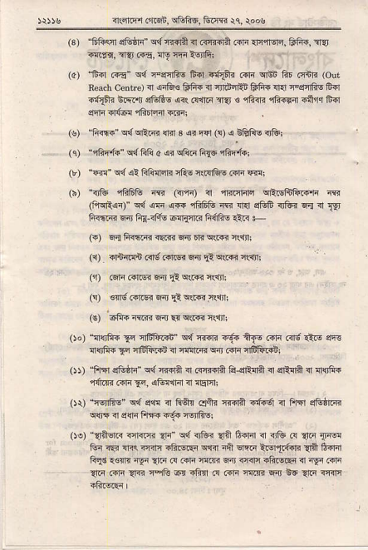
^{?rflrq ffqt, atftF, tutre} {1 {oos
_{(B)} ^{'6lisir} _{sGtF"} ^{q{} r{iA _{n} ^{(rcffn} nnr drrrsr,r, Edia, rT?] i4f'q, :r?r cf5, ^{lrY n'ii} ?91&l
_{(a)} ^{'F{l} _{rr"} ^{q{} _{rerrliE frfl r@ .aF} ^{qe} lir 6bn (our R.a.h cenlro) _{i} ^{qria€} frF. <r nrdiEn frfi{ {r.i Fs:rfiE Err -@i bR"t _{sGli- {<r @1tr aEr s} ^{'ift<R} 4?ir4r Ffflr &ir ^{qrlr} _{a{@} ^{?ll;IEl4;rl} ffir
(s) _{ft@} ^{q"lqF.n} lrir 3 di ^{iar} _{F)} ^{q} t€AE <rtu; ₍₁₎ ^{"rhi{{ qd} FI! c _{{r} ^{qlki} _{FrF} qffi.!
_{(r)} ^{"@ q{ qi} F1ldrn rft6 i(@]&v .{i4 @i
_{(b)} ^{"irtu} ffi6li ft (i,rt _{I mrrFlE} ^{qftqlifterr} R _{(lMqr)"} ^{q{. qF qR} _{ffiffi ffi rrn} ^{q1ifr iii'i 6{ i]} 19 _{fi<!ffi} ^{q} fir <ft EflrI(R FftiE t< +
_{ls)} ^{q{} tiffR rErs 6n _{Et.} ^{q!R?} llnt
(r) _{{n1i{n c{s.il.6r} ^{q{} _{d} ^{qr{r} nqmt
(1) Grr.irFw1rqrR+.rlrl
(!) €ard ^{.{Fr w{} ₁₁ ^{qwr} Rrn;
(r) 6i|i ;rm ^{5ln} _{!l} ^{q{"?} lrlI'r;
_{Oo)} ^{"affftr} _{F crElirrn} ^{q{} rffi iq+ ftfs Fr ffv €rE ar. ^{nqlii} _{tq} afrFrrb <r nlrR w .{ri lEnrsn!
_{Ot ftF1 sG6n"} ^{q{} {iirft a Rr{rl? R $!I? ir srffi <r :nqfir ^{,firiR @f4} _{Ai,} sGffn 31 cE 4r
_{Or)} ^{"arfiiE"} !d e€ n F6i4 clii. Fnil {f+6 r F$J eGhm ^{q$E} rl scri Fi'F "tr-i fsrtr€:
_{Oe)} ^{"4ft6riq ffi} _{{i'} ^{qd} <jliF "nr fidir ?r ^{itu G} {.n 1'@ &{ n!- {lrs rarr +tus.qi s'rir iii ^{6|a} :idr.6+F afi E{Fr Fqd !€!fi4 ^{igi} ?lo _{.{ 4"ri} ]lffi ^{qn} @|n r6.ciF n nyr .nr {r .i]n _{{R} afr @ "fi-4r @ _{.dr} ll:@ ^{6ir Etr} _{1.r} q<m {R|€lcr I
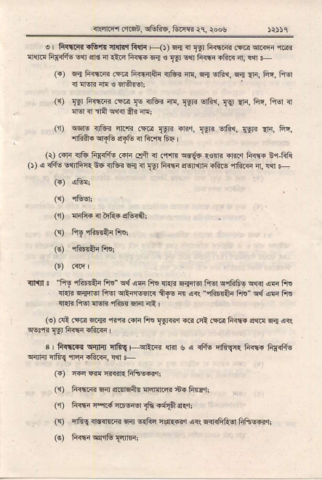
_{4:nntr .ftsi} ^{q6lis} f4m :e, )oo5
o fisiGi s&ir ^{fttqr fifi Fi)) 6a i} _{19' fi<qm .F.r} qrilr "@ 'lltF FrIiFo !q 4€ ir {tq _{li@} ^{q4 s} _{I!]} slt G-r5! rii@ m, rllr F (O o{ fi{iift ^{(@} F<rnftr irtu? _{rr!, s-;!} ^{qhr, €i{} Ar, F{. liq {ffi4 ' r1@.
^{,z !9r} _{F.]@} ^{(m} _{!e} {tu? n.,gF ^{s@.} _{19 F @} ^{-.} d m <tafil elFr ilr 4r.
_{(n)} ^{qqo} _{$€'r} qra< ^{(@} _{1!r"} ^{mr,} _{Xrr} ^{q€i!r,} {sF ri, ft{, ^{'iF.ift. qFtu} s-{E a ft'l! 6=
(\) FF iE liiiftu .ifr eFl I .{$4 wi6 1€nr i|fl{ frffi n"i ft'A _{O)} ^{q} <fG EqnftIr BE nft! €ri ³¹ _{Ts liffi e€nrirr 4fts} ,nfftrn :n, !.n +
(i) {iFR irt l-.sffii
_{G)} Fy rtFrtuft.i
_{.rjt]l : fi! rE iai FrE"} ^{q{} !F fr€ n R 6'!qtq _{liFr} q466$ ^{q"ril} !F Ff. _{ftr<} ^{qaqlr} _{fiEl} ^{qriflFerr<} _{+F} ^{q} _{or\} ^{",iFE} fu _{tu} ^{q4 qF} FrE ^{qmi} fiEt r1!n i6a Efi itt I
_{G) cri im} qnr ^{,nri Rri ft!} _{19mq} € rfr r@ ri@ en s! arr
3 _{F-ftlrF{} ^{qiJlr'} nfi\ +qE R {r"l s a rl4o rfi\r: Fi@ Fq<ftu ^{qnF qrfis} fir aftF, $fl +
(.) @ @f{rr{Frft@rt
(r) liffi w sdr6tu liqi4fir +{ fiTgrr
(r) ^{in6 nad ffin$r} _{{i} stufi er.qt
_{F)} .rfiq:nsirmq{s6!i\{{{rrq<{qirfiturfituffiq!
(€) liffiq{jrtulqrqr,
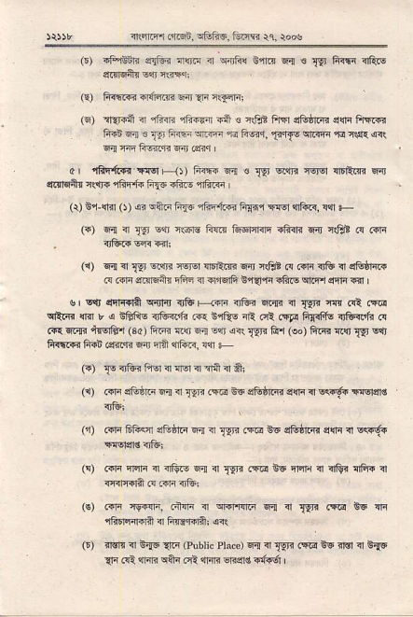
_{)ir5t 414116r.']2.&-n,} ^{uraEc,} ftnjd ri. roos
(r) -Frt n <{ri lrtr.i { ^{q4ft!} o'flF w € _{T$} ii4{i rfuE $:lrdnr s<1 :io"r;
(s) hrffi _{.|+ffi} ^{q-} ?r. i{Frrri
^{(q)} ftF{ ?r !l4rE {r+li.rr {.li { ntriB FFn e{c6rm s$i ftfle Iiin 6.n ! ^{.,9j} i"r.i Er@ ^{,ri fiqr.} _{T..llE} ^{q'rm qi} _{r..1.} q( 64r f4i fts{'n @ .qir I
c, ffir{i{i Tlq Flr) F@ o'] ^{e} _{lpr} @ni EFr lnirm Fir itllrqii{ _{n\rje} ^{,iliFli} h{6 iFiF 4tiF
(r) B,i ^{rfl} _{O) ai} ^{qftr} _{fuc} ^{"fird.€} FiXii $:rs] liFzr, !41 F
(a) €ai ^{n} _{lrt} !<r llw ftm &-6F1n1r ili{F 6n i.!B! @ .ifr ^{qiiF.<} w iil;
(1) 6{ 4llr 5Ffi? &l-r mrim s.ir n€t _{.{ .{ri} ^{?nG} { 9&r1i.? @ rrr erT6ntr Ftstr i1 ilfq|fi E,r{?F "RF qlFr ^{qrli} {'l I
sr slr _{ssrr{l?} ^{qff{} _{nf H{rn} ^{,otur} E{{ ^{il} _{]Fjr} r{ Gl .fu ^{qftR} {isr r ! EtriE irtuc'ft .ar 81tu rE .li .!rF ffift nGli'ft .{ @{ 4{r t@Ai (3ar liF r<r {j cqr ^{!i!} _{WF} 6'.r (oo) Eii? !i'6 g1 !!] fi<r1R FRi ffiqr 6a rrij srfd?, ?{r +
^{(r)} _{Ts <r1B? I"rq ir} ^{qrt} "r nA ir Al
({) ..1n serro 6{ ⁴ _{lln} .m t6 aGrrm _{s{r 4} ^{q4f{} TNrd€
(n) .dn 61+<.r _{tEh6} ^{q{ q} _{Isri} .fu n6 stufim e{ir 11q{d.i anslgls.f-i
_{F)} ^{.i'rr Frqn 4 TfiE 5;! ir} _{lyJl} (58 _{E:6} ^{qfii} <r {G{ cii{ 1 ml{iln @ ftFiitu:
(€) _{c{rn E-+fi .i:,rr ir} qirrm ^{q! ir} _{T{a} .f@ !q n 4inqiTrft 4 Fr€Fr?i <n
_{O) ir.r{ <r} q5 ^{qF (?ublic} PlacD) r'I ^{il} _{Tp?} fiE Bv rl!1 n eitr _{{i.qa} ^{qnr{ qan} _{eR} ^{qrrq} EEqd s:if6i I
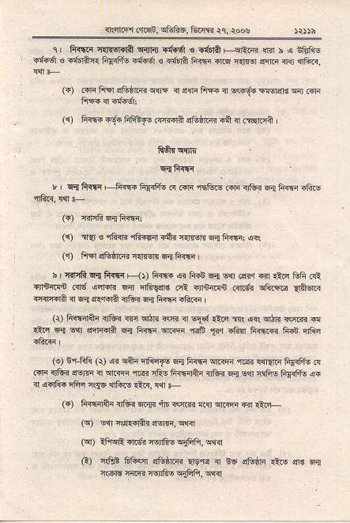
ir'Er.r-furd, ^{qtr@,l-m} rq, {ooe
1 , ft{n _{r r{iq.r?} ^{qdT} Tf$6 € a{rR +qr?.R {l?r h a iffiE iffi s itrfa Fl.itu oir6 . iffl Rffi {rc _{{{{sr} ^{qlrF} <!r {rft?,
(F) .1'lrfl'n _{sE6rm} ^{qc} { sllr FFR { _{s<<+ E{Ersr€} ^{qir} riri (1) Eiffi "6i _{fiF#eE GTtral?} ^{qGdl.n?} sil !r R@rFA
fi.61nqfi
^{q{} +F
_{t} ^{q} _{fi{d;r F -Sffi F|{ifG a ffi} ^{qEtu c} _{Fti na@} ^{qj} frffi iGF
(F) {.rrfiq! 1i6;
⁽¹⁾ na _{€ rF{E} ^{q1i{rir} _{ifir} ^{q{Nnl} _{s-rr Fffit} q(
(r) Frfl s&hR _{€reB} q Ri:n4 |
h Y.F& F{ ii{tr{ Fit Rffi 4i G{t _{r{} ^{sln} .dr.r ^{ri]} _{1:ii} GFi cl tJrnirn _{iirs} ^{qqlir?} _{Fir} ^{qrfua]€} ot .Jrnrdn _{.qig!} ^{qir(@} Ilii$R rmTfla ir _{6{} ^{q{cr{la} _{{fti} ^{qd} liffi -lim
(r) lin4fti irtu _{ar} ^{ql'l?} rsB ir ^{El{i} €ri _{r( @{} ^{qrt{} r"l@ @ _{1i6} En ltt _{eira<A 6{ fi_.ir} qlm ^{"ra$} _{1lq} ifia F{i1n _{FRE} lif.!
(a) Er-tri (r) ₆ qfti ^{qQrfe} _{{a Fffi} ^{q(.ffi qci q{r{F} F4dit @ RF s'FF ^{lfgF} _{ir} ^{q(6 ,nEi} nfu _{Rffid+{} ^{qldi} a{ E1] ^{{FE} _{ffi{€} €{ ir lqlw EFn rq6 4li.s iiR, s{1 +
_{{.)} fi<rn+i r]tui @{r in rcm _{r{,} ^{qt&qn} i<r qtr
(q) sln nrs..riir _{svrF,} qf{l
(q) :Fr{E _{{re rcnliiq rdili,} q?
_{R)} n€d _{ftfi's{l} ^{qftiffi} Egq! i es d66r. liE $€ fl ^{:r.rne ]im} _{@fi-} ^{qdi1ij.} wn
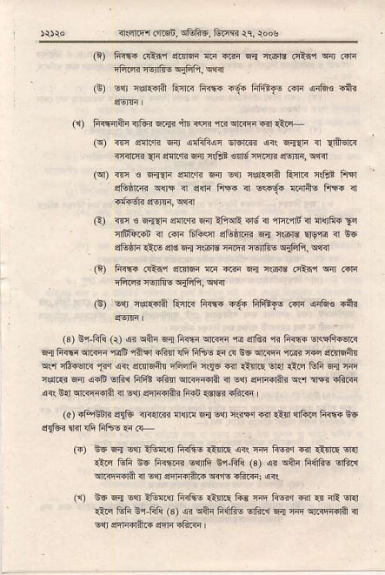
_{Llr} i's .6-
_{Fft4 {€tfi-} qijifi, q€
_{.i .4} .{'.? t=8..@ _{5=a} ^{q€h.} @ i'5d .r.
(1) A{{irAn _{ntui} ^{q{i} irr _{rff r.<} ^{q,rn} +qr *r+
(q) @ elnrE w _{ocliFqi} ^{qdm} !<.. 4{ar n a*qn ^{iFns} _{1rreFr..fi} BFn 1<E? 6riqi
(qr) m € ry{r eftn 6ir Esr *.fi.i..R FI]ri c€t fiqr eF _{d6r} ^{q@} n] sn lffi _{<r} ^{qiqs} Fdr6 FF{ 11 _{Ff{6lr} gsJF, q{rl
_{G) @ €} ^{qq"{ri} slri.E ^{6r} iFrqil'4rs n 4rz4rn n ^{ar{]ft_i} 1q ^{qfinrii} <r ffi lii-qnr s&61.4? F! nr6o q$"rd <r iE
s&la {tE _{ad} ^{qd} +.@lq ffi Tqrft- qftfi, qtil
(n) _{tuF .,ilq,i} ^{qllrF} 6 r@ F{ i€F oti1 w @rn _{rft* {€rfiE} ^{qiffi,} w3r
_{r,,} sd ^{?s6+} _{6T} ^{r'ffi} i6. _{Fat'..di} ^{its} Fii
_{(3) ts4FiF (r) !<} ^{qnr qa} _{lrffi} ^{qFF ,r<} _{edni} ^{qi} _{fi@} qrFflFsrF _{Ed 1i€} ^{qim "ra6} 1ftfi ifi"l !h FfiF ei _{@ EG} ^{qFqn} {@? @ dmqAB ^{qrr} _{nS.E.r} ^{'!ar qrt} e4n6ftr FFFlli lqE -!r _{€n s} ^{!l.l} ii _{i GF} ^{q{} w _{iifi€ 6ir siri} ^{qfir} Fiit .fti wrFFii { slr _{eq1r4rii?} ^{q(l} alIR drm _{d( n1l} ^{qlFF{iril} ir E$ ar-r-rftq fiiB _{{€]e} .li@
(o) _{rtuiiq} ^{qlir} ir..rR flltd 61 -qr +.ffi"i €ii €?r {]fi'F fiiii5 t_6 s9lii fid _{fi ffio.a} (F
({) ₊₆ ^{q{} s".! ?&{q fRli- _{€Rs} ^{qir} m liqr rir €{.E Errr {.8 trfi is Fiffi sqrfi El-Flii (3) _{!r} ^{qah} F,ihc srft"r ^{q.n} _{{il n} ^{Elr} _{erlndfti} ^{qi'rs} ?ftFi d<.\
^{(r) B6 r{ e1l} i&{q iFfiF €rEE lic m liqq rir .{ rE or1l _{r:j3 Efl Er-Eft (s) ar} ^{q+i} F4tus lrfr.n lia _{w} ^{qFFi'lit} n1 Err cn4{r}.. enn ih.4r
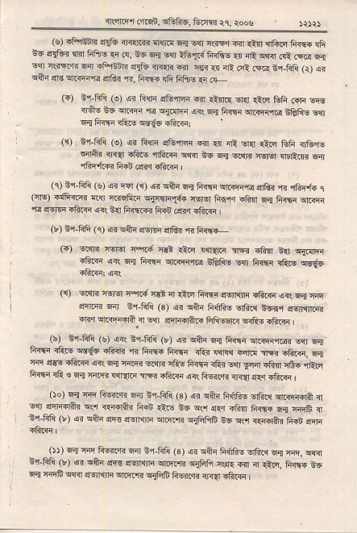
Er::P rr$, trtuftf, feEc {q roo,
(s) if"lnin _{sltu} qT{rn ^{ql@} E1 Eai .r<Fr -.r ?l:r1 ^{,n1iF} liiF {Fi d6 .r9Ed Erir 6ii,! .i tr, !6 !i{ !..! i6ti FRft- ?l nE s1ir @i c4@ 6{ E?t c$r.rr r{ .l;1inE aItu nF{ri.ir i€r .l ai re (m i,i-tui (r) (i ^{qftr} _{ad} ^{q(@,rd} _{d'&r} ^{"1i.} li.rF+ s& Ftus {i @-
_{F)} nl fr1i (o) ai _{fin} ^{qErln} ii {l!r! sr{ rQq ffi @ sqs _{<6t- Eo} ^{qi@ "rq} !1i{lF <ir sn! _{trffi} ^{qftrFq@} EERE s",1 ^{q{} h<fi _{ifuE} ^{qd-!6} iftF;
(1) Gr-ftli (e) _{ar F1F} ^{qG,ffi} a .l _{np} ^{q.r} lirq Fti <rturc ^{e+iir} _{r<{ ift!} ^{,iftF ql|4r} e6 6,! ^{si{F} rq,q ftFiR 6il 1iir+€ ffi rE{r rliF I
(c) n1-frli (s) oi _{r4r (!r)} ^{q? qilr} _{E{ Fffi} qiri?ri qtt?r ^{,fr} rfiFti 1 _{Fls)} ^{.fF@} _{{q nRifin} qjqsrrT{i {srsr fiiifi -li'.n F-,! _{F@} qr.,in rE ^{,rff} _{ifiF} ^{qir} s{r Fi<@ tiii crir ^{iftF} l
(') nl lifi (q) _{ar} ^{qtu} e€r?F _{srl&r} ^{'n} F.r@
_{(.)} ^{qnrr} 4€rq F.i {€r <:F r{qtzi _{TR ifi4 Rqr} q{m ?ftr ^{qirq} _{ii6} ^{qrfi-rrE} iEF- er, _{tiffi rftls} q6Y6
(r) wn? ftFr ^{rm{} n€n 4 .-n hrF ?fsin5n _{rF$} ^{q..r q{} F lirm 6nJ lr,ft.l! (3) _{ar} ^{q+r} _{Fdlis} ^{qfi..r} s6iq ef5l1r6i iri{ er.lr@ft I &n eq&Ar{ _{Fli--rR} ^{qitu} .tud
(b) Br-fri (s) o?{ tsr FIi (r) _{o<} ^{qqir} Ei! _{Fffi} ^{qzrirrc} -sr s{ turi iftE w€6 *lin n ti@ fiffi ito 4n!q _{€ril ]m +ftF,} qi n lr€s _{iftF} qn q4 i.l@ s.?,Tr rFE F,ffi <G? ^{E{r} r{.n .fiin _{16{} .rEq 1iffi rE € 6,1 w,ir {1r?F ffi di@ <n Fu{rR <r{a {:q iftF
(b) tli m Fw,ri ffi i'l-Fti _{(s)} ^{qi qtu} F6f.i- 6riid ^{qrc{h{{a} { slr _{srF.rih} ^{qrl} {.{irar tur riF _{e6} qrrl ^{q{r} _{iti"r} ji.rf4 ^{q{} {4qi, n _{$r-ftlii (r)} ^{qr q+r} _{sR} qqrrin qrz,E ^{qcFf,r$} _{E6} ^{q.r} i.ftA3 FRi eqri
O, sr m lidrr @ n1 _{fit! (s)} ^{qi} cft.r fiffi- dfrt! ^{q1} _{rir,} qq sr-Fji (r) _{ar} ^{q+r} _{eft {lrFma} ^{qnri-ri} qftn ?$E rir 4 ilie. li@ !'5 _{F{ Titr6} ^{qqd} _{esn1nr} qitf.R ^{qiia$} |iwqi irra rftF
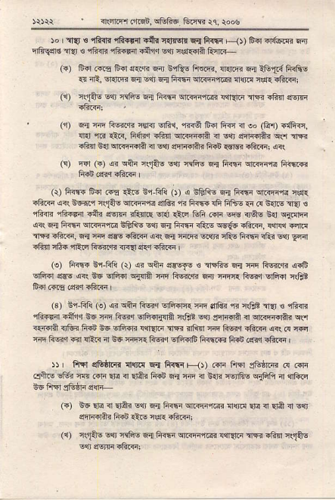
{:lim,.]i'B f,fr6r tuF rq, roob
_{b I a]{ €} ^{'1fi{r} rE{trjl .frr rdc€rn F{ li{r{ F<t trd .r{@R 6j ^{qfi9cld} _{ftr €} ^{.ili{ri 'il?if,n} inqq s?t ^{i(.d!ina} Rnr.n_
(.) trir @r &.i {rrR 6;u Ed16 ftni'.j, {mF ^{q{} tlnti FRfi- {4 "R, _{cr.tqr} ^{q4} _{!{r} ^{q{} _{Fffi} ^{qriF r@ at{rd} _{rf{} iErTri
('r) iqiE E"n _{468 E1 ft?tr4} ^{q,.4iariln :r1i1r.i} rr ilirl ee-F <Fmj
('i) 6{ @ 1iw4i r€rir srft'r, r.r€1 Flll ftii i] !, (1i1 iifiq, llrl m {ilr, F<ld _{rlifi} ^{qR@rA} n e1J _{enF_itAi} ^{qln} alyi rdq!']:r@a 4ffi@qf,rr*?, 4
(!) ft] (i) _{{r} ^{qtu} r(F- E$ _{nF- 5i fri5i} ^{qirnr} FRi1F fi.i rsir aft< |
(i) FrF ftr FE 1iE ^{fi tri} _{O) a lraaE} ^{qq} _{F{{r} ^{q} cr f { N1 _{iiF} ^{qi(} +@q _{+qA-} ^{qrr@rc} aG? i< 6rr{ {fi Fl+- 5 F s.rF _{aEr} ( ^{'din} _{4?rr{ .i_r} ^{qE} n rR{l.q lr1r ^{qi.i} _{trr ffi w <rO-} ^{g{} qrqF air 6rd _{r+4.ir} ^{qrirq,r,r@} BftFs E1j _{6{ fiffi ift.E} ^{qce6} "fiF, {'f4. .rlG _{3FR aftF,} ^{q{} _{tr $s +F.q s( F{ :ffi} ^{q'{r} nF-! hrfi rlfu E ^{n} E{ir _{ilirn n6r} ^{qi6} liwqi <r{{ !r.r -ftF I
_{(a) Firh tsr-Fji (r) {i} ^{qtu} essTe { _{arFliE} ^{q{} {rr ri6{i'E dr'F ^{glFF} _{er@} ^{q1b6 qlir qjtnnr} m R-e:?i'fi Eir ^{:ri-n} liqr dFiir r.Gr
(31 ir F1i _{(e)} ^{qi qftr} ftqq ErFfi{{ ffi $&? ^{q<} +,qt nsj € ,jBili rli{r.i {q'i{ n6 F ftqr srli+iTini niBt ^{s<r} sn|ntrir _{il} qrFFiRritr q<r ^{?ei ator ea,i} !E E?n !aq? ^{rr} i5q @ _{trE"} ^{rtir} '", @ ry _{n i@c.n} ^{qilF} n e6:irF{ Fq.r dFiir6fiiffi tui rq3r.ftF
!) _{Fl!F1 d&hrT{ ftra} ^{q_{} fr{Ir F-1, ^{.4lr ftn} se&rr .! .-f4 ,:lfts dn1 fr li|a Era 4 Eift FFi 6{ ffi ir 6{i _{{orff€} ^{qiqn} { $ftr
({) ^{BF} _{Er!} ^{ir} _{Flftr} se.! _{Fr fiffi} qt@,r@i qliF ^{qre} rl ElA I s"r] oftftdh Flin €!E f.5E ili.Fr
^{(r)} xFE E1' niaE 6;n _{fi<.r;r} ^{qrFrrr<r} _{!{l{trn} ^{-4qi.Fn} c{iIAE
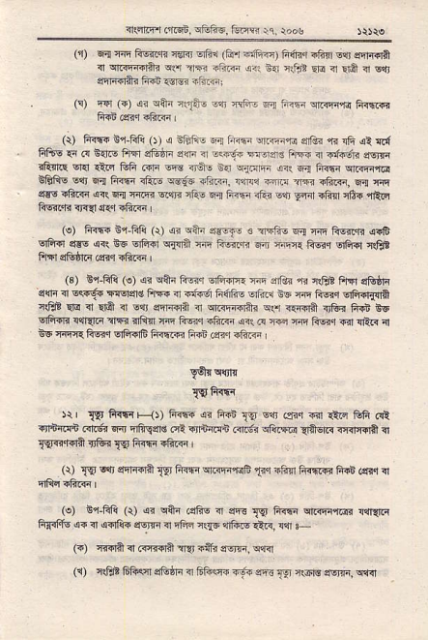
+rftq- ,cn rtoftT, _{i(.E} ^{q.} rros
₍₁₎ ^{q'!} m'r Fw"F rEF ^{Eri i} _{1L!!} ^{t'.iF--F)} li{i{ risr ^{B{} sqn+rA _{ir} ^{qrr@Tirar q5} ?E3 riinii !?. $.r l1Frt Ere n Fil it sli ^{qlmrni} F-i r3E altr|! :
_{(!) Eal ({) ei} ^{qaF} nltii !n RF- .c icin ^{s,rFF,r<} liiIR li{i.er.r.ftF
(r) F?tri n,i tri (r) < irilft r ..r _{ft@} ^{q.+ira} er€i rr _{rfi} ^{qi} {r{ fi&E € d E{lF irFl eGiri 3ri r dr;. 'F .iz FFF ir3fd.< s.m isrine sp rFnr _{R4 '} ⁻ )Fr
Efr&E E{' G{ Fr{n itur r€ic _{rii;i|ir. rn{ -16} ^{'ffi} {,lirrn, Ea {n arirq _{"l?(rq} ^{qil} _{6{} ^{]rl@} @rj itu E{ li@ iii ^{sql} era _{Rftr c6.} "nid
(e) fi<r{ Br-hii (r) _{ai} ^{qiF} {6dtr . .FF- 6{ F{i Fwri (iF 9lFl{l _{e@} ^{q(} te Eiiii q{il m fiwq .ir ir.ft liqq oft{ rlB!
(3) _{Br-FIi (e)} ^{q? qtu} fts 6FFrE ff i€i,ra nlEri ftFr s&tlr sqli i w6.. Fqqld FF{ ?r Fi-6 ft,itu .tft.{ tu m ft-6rq ErFi$r$]fl c{i? ^{qE} i Ilit ir lar ^{qrFia} _{n} ^{q.iF{irtu q9} <fi{fit nFlqj lid EF ^{qftT} ra Rr1l.r ffr irlir'll ffi liq.J .ftF ai! i{ i+r ffi _{Fq{ in {ER} ;l1 _{iFF {{R6r} ^{qFFr6fiirm} 6(E ^{(srr} di@ r
yqi cvln
Fli*a
^{)r,} _{]Yr} ^{ffT{rF<J) li@ {? tut} _{Iql} slr .?l3r {ir.ts Efi rlt inr,riqn .mii w nfiqc'd _{ot vrffi .ilr6} ^{q&Ftu} ll+tr isr{+fi . _{Tqni.ffin} ^{3re<} _{I9} fiffi {ftrn
^{(\)} _{Tqr} !'n ^{cd{+r?} _{TY' li{.ii} ^{ql.r!-{ rq6} _{1!q} atur lirr?G ffi Gnr rl
(e) B,i-fiQ (r) _{ar} ^{qtu .s1i- { @} _{E F..r.i} ^{qr.qra6{} {r{.i Fr{rfl€ dr <r €d1t+ oE {? _{I} ^{qr-4,} irss ^{"r]tu!} 1li<, w F
(i) {.{il { cFi'lA ?q,.lt< e!j'n, !,n1
(!) i$t frliq etu F <r SliF ni. sft !!l n(lrlg _{e.m!} qlRl
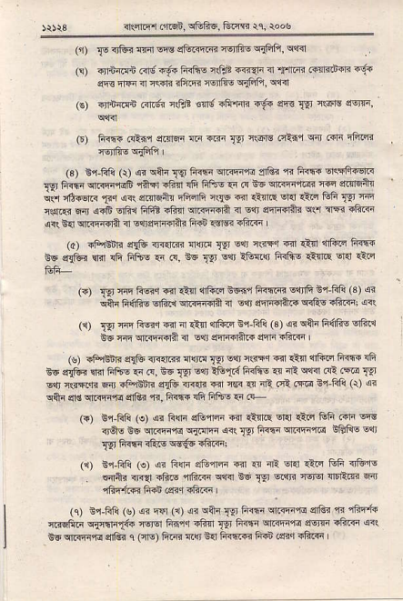
i1.irFr _{m!F,} ^{qfuFE,} &im ic, r.o$
^{('r} _{IsdFF} @!dt!r3nE {oqif'f'w
i$ ffn"tEn .<lg f-6. iRfto _{n@ T€{i i]} ^{'FiEn} .atrr{daF iq{ ^{q@} _{fiF} ^{,n} :\tn _{?ft@ wtfis} q{Fth, qlRr
(s) !5-ri .:@ ^{r{?t} 6o€ 4rafi ?gd @ ^{:f9i} E! 6g@,
o) F{\? .€.'1 edFr !6 ^{"rrr} _{19 *.6rs cRi'i} ^{qn} idr EftB _{@.ifiE} ^{q1ftFl} I
(s) E{'F1i _{(r)} ^{q qqr} _{Iw ftF} ^{qr.qrt{} _{sii?} ^{'r,} fiffi crcltF{slR rE _{lkfi} ^{qr.{qa'E$ 'lild} rlirfi !fr 6fts I'{ F _{EE} ^{q.4rri.!?} @ drfi.fft ^{q',"sr.} _{t.r} ' 4 dctF,r, ehd 4V5 c {!re @ ,"tc ^{tq} _{t9} .+ _{?{@ n .cqF} ^{q-F t'A} _{ft.r} sl.r'n6ir 4 d _{sFi6i'r} ^{q*} {E ffi _{lcR bd} ^{qr<i-d+} i lBrdqrfti. fi+b.dqr rRr<n
(a) rffi'Bn sf& n{{r.{. ^{:n{rF} _{Tr} E{t rsFq @l €r1 $'fiF FF5?' Bc d{fr_. rr1 i1i fffbE ad .{, ^{Be} _{IlJ} ^{gl'} iF4$ FRlis _{ltsli!} sla €.r
^{(a)} _{!91} fr hw _{@ dt} ^{qr€q} _{6Fs"} +d*!-' w1 b{ Fi ' 3r s liAn FffrE _{oft.l} ^{qRFffft} _{rl} ^{sq} _{!!rr{'ird} ^{qrfu} dflG. a ^{(r)} _{Ni fr} ^{'46q q} { rtur ct6r! cr-.!'{ rs | !i s+i fd{io ofc _{cE ffi} ^{qrq{.ri} {r sqr _{!!r{+Iir4 lFF} 6ft@ '
(s) iFr$ri sle inlinr ^{ll{lrc} _{lgr} ^{qt} r's!l .r1 €{ sll6F f'frta rfi ^{g6srtu} $dFftE tn @, e61!'Eln i6t FRIis _{< afr} ^{q{rl fi iM} lYl s$ n(irl$r 6ir.FFnf. e!& il<4? €i]€i _{{r} ill f€ .M E+RG (\) si ^{qflr} _{4d} ^{qlrqrtq qrG?} fi, li<r$ IG Ffts !:r .e
(.) br-fili (e) @ Rqr eErtF {rl _{1t{la E|d} ^{qid} _{&fr .41i} q! irqs _{EG} qiirflq ^{q.ntir dr(} _{I9t E{ta} ^{q.qrra} EBFg s1t _{IF} Fatr{ ifts s!{6 {ftrr;
(q) Er-F1i _{(e)} ^{qr} &m s64F @r {, irl dld 1tq Gfi <,&'1., . ^{qlir} <ri{l _{rfi.s} 'ift.€ ^{q$<r E!;} _{lYt} ^{qrqr} wrEl llEEe Fr rfirrtn Fd dr<rfto r
_{(r) Er-Fli (s)} ^{q<} irr _{(r) 4n} ^{qftr} _{{9 fiffi} qiirri'r-{ qrGr ^{"rj} rFq{{ _{il.lrFd} ^{qrrirt{-} rElvl Firi ^{Ffin} _{tPl frrli} ^{qRF{"rd} sqrr afr.in @( _{EE} ^{qrGF,rd} _{dftq} ^{q} ifiE) 1im {$ sd frrll@ FRn ienr rftrr
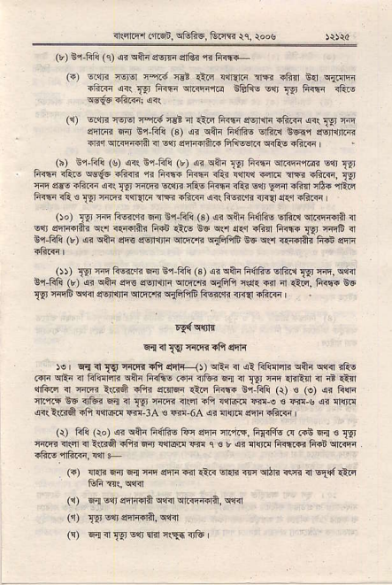
sr,ftqil _{.rd,} ^{q&R6,} Ginm $, toos
_{(v) Eq'Fli (e)} q? qAn ^{qsrF} _{dl&} ^{,ri} fr{F{-
_{F)} Erqri rGrq rq.i f€r €n lqr{ri 1fr rtu Bd qdtrr _{ili.F} ^{q<(} _{tFr 1i{nn} ^{qirrrre !6Rs ${r} _{Nr} ft<\r i€iE ^{qqgq} {rir{4 4r(
_{({)} ^{q1r<} FJgl c"'r.{ clt d €Er _{Rff{} ^{qErlltr} _{.frKi} ^{q<(} _{i!l'} {ir eftq{ lrrr 6r,Fft ₁₃₎ ^{q? qfu} fi{frs vfid E6{'t iErl{ftin _{d.r} ^{qrr@d*} ir sqt enndft." _{frRlqr{} ^{qrR6} r'ftri I
'hr E.-tft ruJ i? ^{c--LF (q, s e6_i} _{Tpr} ln6 e]@!@ ^{w} 9Qr iffi _{liF} ^{q46} !_trr - _{F'@ F'6 d{?} lNa {nF ilr ^{!toF.} r\' qrq ahlE .FFi ^{4r(} _{IIT} 'lrrFi ^{qlq} _{rtu 1i<rr iRr} ^{qq'} _{vlrd} .hTl rBflrR.'r ^{hT.n rR r} _{IYl rder {"fi{l{r :la rftq} ^{q<(} FE<..ri <rqr s{q "ftrq
^{')o/} _{IYr} 'E Fva6 @ €r-tr! (3) _{!i} ^{qcn} Fff@ @f@ s.Mjd r _{w} ^{qiFir} s nffiAR ^{+.i} _{drE Ge} ^{q.r} qF ^{6ar +@} _{!!r} FdqG ? _{tr-Ffi (r)} ^{qr qai} _{e@ sEiti4} ^{q''RT. qifiFiF} Es cl'l r€fi+i R$ el{lr
_{At TlrE} t!'*,ft w e'i F{ (s, !{ _{EAi t4frs} ^{qii.i} _{!9r@,} q6 ^{Cr-i''t} _{rrj G} ^{qlE} _{ers 6rr{i?} ^{qrrE} _{rr} ^{qr?"} _{@r} ^{q ?} _{{tt.} ^{+!F} w rJ\Ir 'r4EF Eq4 _{6vF} ^{q'il@} _{siFrffi} ^{qsR.R} {.{ df@ |
^{F{ i} _{I9 frrF{rfl} qrF
_{)e} ^{q d} _{IW} rtFt ^{tfir} _{s{i--{,} s}n { {t _{VdFri} ^{qir} !@ rls @ ^{qtd q} rfffi str ^{+.itE} _{.e} ^{q16.} Fd { _{i!]} ^{'+} {I'ren { 4 {tF ^{qtuq} n ^{riEr} l(rr* _{ai;ri} ^{qmin} €ir fi<nr E,i fili (r) _{! (e)} ^{qr} filri _{tttT !e} ^{:316{} _{v4} ^{ql} rI! ^{'fii{i} _{sn rft Iqr@ w,e ! @+} ^{qr} {{rc ^{.qr(} l(F6i rFi firiR{ r.r{-lA € @ _{6A} ^{q?} _{{{,.c} ^{qqf{.F.ilr} I
(i) Fli (ro) {n cqr frfhs ftr s5li rt'ie, Fr{.frq @ RS F{ e rv fl.Fr ien i ?(rrd _{r1i< E4r !qtq.! w} ^{q} _{s r} ^{q} !r!rF firms FrS clRqi rFiE i6rT1 r{ F
(.) {{F .rir ^{q{} nc rtra_{ €r {.! ^{qdr} _{rli} ^{qrtln} rafi { $1( €Fr _{tuF d!} qqd
_{rr,} q{wqFf,{e sfr r.€qa, w
⁽¹ _{{gr} sqr ^{qrfial?,} srd
(!) ^{q;l i} _{1!r} n{r sr.r Rr{d:"le I
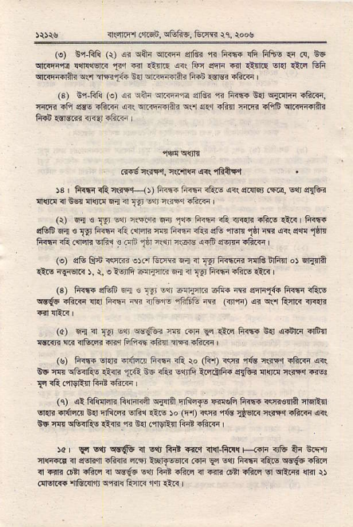
_{{(nrrE .{rqi,} ^{q&ftF,} fum rq, roos
(e) E 1-Gli _{(r)} qr qtu qrm ^{qiar "n} fiffi !ft Ffto :a .1, eF ^{qrrr;Ff{} _{!$q{qr.} ^{'!+1} rqr ltfir{ ar! fur a'li rril _{d{r.!} qd ^{qilr} Efi _{etriF.1?r} ^{qrri} a1RTft _{E{} ^{qffi.la?} fiat €rB <l?@ |
(3) Br-Fft (o) (i ^{qtu qr.rq:r"rq} arRi {-r fi{r{ Ed q.{6r {ftq, fiIrr _{i1?} ^{q.s .rfi.q} _{a<(} qRrr{rfti qr'l ^{q.q} _{ifi{r rrFi {in$} q.<ReBr ffi {qrsr{r {.qr .fi.F
.r46cs*r, aeiE sr( "frn*|
$ i ftf{rRcs+ _{1t} fi<n? li{{ri1iN 6(qi1iq, ('q, gl'qEr {{rd i] Rq ^{{{,iq w{ 4} _{1!r} !9 rffd FF.{q I
_{(r)} ^{q{ e} _{1gr} Eqr _{r(!,cR} ^{qn} _{1{r.66} rR <r<{?.liF 1i.. fi<5< dtu6 w ^{s} _{e} Ri5r rR (r|rR ^{q4} _{fr{ri lRi} ^{qG rlsn} _{dr} rB €\ ^{dq!} til, F<nrifi crr r slfr! € ^{orrn} _{dr +.11l +.6rs} ^{q-F} erq,Fifi.q j
(e) s& Qri w..< sror &.m Fj ir 'tFi ft{..< lnl8 aFm or 6rmn rt.q nFrqtr ), r, e lsift _{s!Ii]l.r} ^{q!} _{a} j9' fi<fi .hF *.r I (s) fttr€ sGS ^{6.i €} _{llr} en rflirr|G cli'{ rrs siq]r,t{$ R_{,{r rQe w{5 _{"fit{r} ^{qq} Fa'i ^{d irturs rGGfr R} _{Fi'rd {i} ^{q*l} futr rFdt
^{(?)} m < _{xr s4r} ^{qq9iu} @ .{F _{F} ^{qin} h_@ s{ asrr .lBfl _{ftr{r !a} ^{q&.'n} fir.i trhq +F'1 :r4q iftq I
(s) _{F{f{} ^{q{r} !r{q.! fr{.r rR ro _{6{r)} rs{, ft caEl| rairr aR _{!E w} ^{q@} _{1iii<} ^{"lt:€} E_6 <fti Eqtrfi lrqd i{ ^{q6?} {{rF rttr{.r i@ _{1|l} ra {49F,| ftd rftqr I
_{ri) r?} ^{riftft} _{ftrdRi'} ^{qf.le} FS-to ^{l'ftf'} l{@ G€re 4Eitn ^{q{. qfrB} _{64 afrd} ^{qtu} (rs ⁵⁰ _{rr, rq} ^{-d!} _{Ejiw} '$!' _{!ftF} qq Et. _{r!!} ^{qfft<lfu} _{€{r} ^{'n} Bd .'nvAfi @ <Far I
rc _{yr} ^{g{' ls@} d €t|, ftr €( rFIRR{ F-{*F 4& ai E 5,t _{i{{s6 i} ^{qEn"} _{r'F{ri} ^{q14r} lqrlselr_{ ^{.ar} Yl w Fmr rRro vc{* rFio d T|fi .dl rfirq n _{w{6} ^{qar} Fi! .Fr.| _{i} ^{qh} _{6!1rF.|I} ^{q qrttrfi} {tfi r) 6'F R 1&.al'B wf<l! _{RcfR} ^{'r.t} liR I
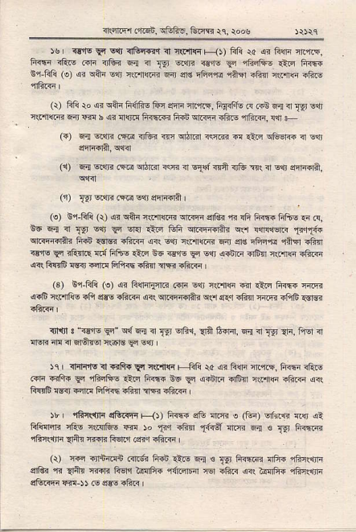
{!{Fr Lfr6n, f,li:, tue rc. rooe
)e I vls _{Eq} sqr ^{qF.f{il} ? r\i.ir|r +lt Ffi ra {i F{F ftrin, F@ ift! .irr 4E? E{ ^{ir} _{1rr} elrr3 €r! _{En} 4',nRE An Fi@ ir fiJi (e) _{ar} ^{q+4} Err _{lrrn@ 6;r} ^{qe} ffiirs ri€ <E{ rcirF -ft-
(!) Fni ro _{si} ^{qRr} fiilft- tun eqn ^{'li'l-F,} _{M.r-} 6 Fn q ^{i} _{Ig} E{l ar @ 6;n w b ar _{!r!F ftnffi Frai} ^{qr<!r.hF} miaR, rr F (r) _{E1} ^{q{r?} _{,s@} ^{qtui} _{ffi} ^{qti} i(!R d _{riR} ^{qc.e6} i s$ fiiftlA, vlr{
(1) _{6{6R!? .mqilr.n <Fir} ^{qiTnft} ir& sr <tE?8 ?l'rrr{r;rl q?|<l
^{i,} _{r.rm.In?} o4ffii
(e) _{i'r-Flii (\) si} ^{qin} _{r${@} ^{qrriqa} {rftr _{{.J} ^{qft} li@ Flff-.n n. n6 ^{E{ 31} _{T9r} ^{!"i} _{Fr} en ll.i _{lifr} qRTo?a qr rlnq1Er.F 1i.r1ia qr@{irAi fiii {sr@ _{iftF} ^{qnr} s,n ir.rnffi _{Fr er.} ^{qFFft} r+fl rF{r ^{irru} _{9<} <Enn mi Ffi;c arn ^{+c {€'fs} _{F E.n} ^{qiitri} ofr"r *rnm ?Eft {nFF 6 l@ €rrl Fftih.fir aFln iftF
(3) B1-Fli (!) si FqrirFrR .i5rr -,{r r(r''rrrq ii] 1iri _{li@} ir:@ _{<.8 lllrlic ili} ^{q€E} _{rft< <<r} qRFfiiji qsr ^{q€} ili,r ^{'i-@} iAF .Brs
_{n]lJl 3} ^{"<€5rs} _{9r"} ^{q{ fj <r} _{{!r} ^{€rliir,} aa _{bfF],} ^{q{ ir} _{T9} qF, fiF.l <l _{nvR @ ir} ^{q€lTor +.6]!} _{F} slt
)rr {:nrn6 i Fift+ y{ ^{q(.'i{r} F -q! \a ar Ffi iir.F. 1i6 iiirE ^{@ -rft{} Ei rFFft- Atq fr@ ^{EF} _{F} aiftr rtrn lens _{=to<} qir _{nR&} ^{qdn} inF Fl!rl.6 {fti arR iftq
5r ' rFRrfi ^{qBnq{} ts<t Fi@ .ii {F? o (En) vf<€ {s ei trsnar? cF.o ntnrftio rn ^{)o} _{"q} ^{.lin} _{Tf{ef} arn? Fx € _{l'aj} Frffi cGir.r]lr 4nr {..R 1i€r.'r re?r aGF I
(r) @ r,,ra\i{n c{.64 li{b €lE F,.r ! _{Tq} fi+nrr4 {ii{ rFj$nr ^{qrGr "n} _{1rn"} nRr? Fsn _{i$rfts} ^{'rnLffi} _{T6r ift? lrr rslrlii} ,iEr{.r]ln ^{qturrFr} e-) J .o e-@ rfti r
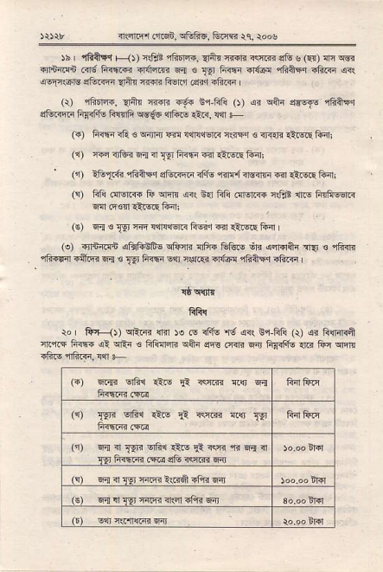
_{o.i@ ,Tci,} ^{qtr@, tua} _{rq, roo} !
_{)s rFAFq ts(, i€E} ^{,i.q'rn.} dn {iir? <ffi eG ^{u} _{@)} ^{qrr} @ _{€l+iFi .fi; fi.F@ -r{rffi} ^{qqr €} _{-{!r F@ {,riF} ^{,iiaFr} _{Ffi@} q<r _{<q:isrM} ^{gtuffi} {irr r{<t F€n'i(siq.1iF
(r) rftIrF. q'nr ^{{dd" €.6 Ef-ftlii} _{O) sr} ^{qAr} _{s€rfE} qli+F"r aiinftr futu _{Frifi wio} ^{",lftE} €ri, +n -
(-) _{1iffi <ft €} ^{qinrj} m !{r!l€ft? nrnFr € rF{n itEiF tuir!
(1) ffi ifiu ciq ¹ _{Tq} ftm .ir itqs li.ni
' (1) ?tuA:fi _{4?A"r} ^{qrE-m} rf.F. r{rl iMirF -n i?q.s fi'xi
(s) _{fti .Il.@ tu} ^{qnF} lrl B{l _{ffi .lrq@ itrE} ^{.nrE} fqfillEr.< .r{ 6s:n t s.s liirt
(€) 4{ € _{T.gt} w !{Flw Ecir "n €!q! tuir
_{(!) rjrffi} ^{qtuftiii- qtum.} {ft{ ffio \tri diro+r aqJ € 4in ^{qli.Far qller} m € _{Tr'} F@ _{-qr} ^{q$rcn} rifl thftqq ii?6 r
\}q'lrF
fifr{
ro ii4 _{1t} ^{qrim} {r"r )e ca _{rFfs} "6 ^{q<(} sr ftlii _{(r)} ^{qi} lilFl{it i.rF _{Fi@ {!} ^{qFn} € _{FliTqF} ^{qA"} eE .rrR trnj FFifF. rrG _{lii} qfi.
(.) 6r{1 Ertu {iF _{!1} +]@ Rs E-!
⁽¹⁾ _{TEJr} vrFr tE _{d} ^{ffi r{r} 1gr
('i) ^{6{ ir} _{TPri} ^{qtu €o} _{F} rs {i 6.1 3l
_{t-gr firftn} ^{(@} _{stu} ^{lre} 6{
⁶⁴ ⁴ _{t?r} ]J@ ^{-.6d} ff .i4
fivTariffi4.irrfFF
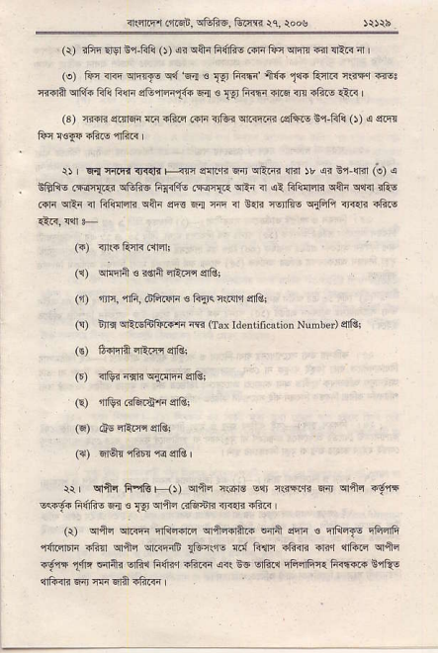
irinB _{rfBin,} ^{5f'1i5,} to]m ^{i} e, _{\oo} !
(r) _{rftr} qlg ^{i,1-F1!} _{O) sr} ^{q+i} _{F(&6 ldr tur} ^{qrqTa} _{rar} ^{qRR} a ' (s) _{Fn @} ^{qETJE q{} 6{ . _{{9} ^{F6 lt{e} _{11i} knR it{ir @l _{Filn} ^{qF,6} _{tri elri atul{i1f+} ^{q{ €} _{Tri} Fr{rr r'rc nn iFr-s {lr! |
(3) rtr{8 edrqn tr iBF r{rr ^{.tui wirR rsFn- fi Fft} _{O)} o eR . tun !6ra rftE 1ftr
$ q{ ^{rFniir} _{fi{n |+{} ^{qan"R} E _{n} ^{qrim} ffi rr 4? _{b"l} ^{qir} _{G)} s EEIIE _{6<l{..r} ^{qGft@} _{Fq<ftu F@a..} ^{qEi} ir _{si fifinf4i} ^{q+i qlri} rf@ _{Grn} ^{qrli} _{{ FdiFifir} ^{qi}i} eE Ea rir n B!]? _{isiEl!} qBA <F.ri ift-
(i) ijl(i Rrrr clFni
₍₁₎ ^{qrlqlft} s i€la 4Frc. si?i
(0 rin, {6, dft4F s FF<crFr'i $Ai
_{(!) lrr3} ^{q'EF€fr@R} @ Oax ldeniincaiion Numbcr) 4lOr (c) €4l.fi {Emsfit
_{F) ?lG? {qn} ^{q{.qn} ?riQ!
(o {fti Gffiin sill
⁽⁶⁾ ds4tF afsi
_{(i')} ^{qr6tr} _{ffiF} ^{.1<} s{i I
_{rr,} ^{qr+q} fi.{t _{H))} ^{qfti} r\or€ -'rr _{i(iFrE 6r} ^{qiq} rd.n E<r!'s _{Frifis} ^{qa €} _{Is} ^{qr+q} tr@ij {a{r iftr
_{(r)} ^{qrftq qiiF} _{iii]f{fF} qrS*rft.i di]it _{dfi !} qrliql€ qF<fi ^{'fitqtfii} _{ift'r} qriq ^{qFqnF} _{tfr'nias si ft4llq ift{< @r} rn1i.u qrii ^{i-d.q5} _{dir} 6{fti srtu h,{Rq iftq 4it i6 Erftr iFFlG:1liiri@ erQ! affi'ili Fa wqlft iftF
_{a@c!.nEn,} ^{qftfiE,} tum {q, roos
_{-_} (e) eEriF< 6lft d€ s _{ngf{s rffi} ^{,rft!r,4} _{<F*l} ^{qffr $Ers} €trs ^{q.fl} ireq rFnr fi{tr{l? dr{Fitr .rf6n.i.i.n Fli6lgnr ifia irv{ _{sFE} ^{qi4r} ralr _{ilR{} ge? ^{,r.rr} _{ffi} ^{qqc qrR"B} il} ^{(s.ir} .frF (3) q;ir..6,r.8 ^{qriE r} rqs rtu nrj €ir
(a) _{li{tr EEqiq{} ^{qrR.i} I ^{(dq)} liFr? lil' E{ <E{ftr sftF I
Nr an _{d rFnnfi} ^{q€} € o{rd? _{*fr r-al FIiqqF} ^{qfia} Rti@ {]a lilt 1tE{ ir .rr, @, ci61, sG."F{, _{rF+.lrr} ^{qFGri} _{it} ^{qn} {dr rFjq ir ddq da tui,rqc{ ^{(cl&rig $r+,} _{d?rR} ^{qljEr} 31 @n rldfr} _{fre{r <r} qsftr ^{qwq} dd € ,{rr rat ql?E
^ :3 ftr|{r € ^{qfrt} r{_crs cqrird _{+ rr} ^{p@} h ! _{b} ^{jr} tuFtw 6l{ :ir ^{q.@} $1r snf@ ' _{x,} ^{ira} € ^{ti..4r q4} +.)o.o$!atlFl1qi _{F{ tuG} ^{q@} _{{3{} ^{q,t@} , b, rF @ |.D@ r.s !{ tzt _{)J} €r..!Fl1!1f _{Tt,} ^{i6} ffi< ert{ E':dr _{(!a,} ^{cr4} _{n} ^{qnd} nl{ hnF ^{lF.nlr} h-rtt
(\) _{Fli !e} ^{q q+i 6{ <r} _{1!r} rRR dir lrij cr.iF ar( _{F1i rs @} qar ^{s{r} _{*.'iffi} ^{qirr4 aft?} _{0a)} r@ +{ _{ft{iF aRr B6} ^{qlRln} ffi rfts €Rl
ra I afufi \'!., c(rl1r{r d{-ft!{ € r\!{ _{{fu} ^{qfrr{F} |-41 Ffirr4n R{r]cftE {{l frtt {1q{ _{n} (rn, qr]qre{ !fl.E i sr Rrfto ir& _{ftq i} gli r'in5" ^{r--@} r,'n F _{ffi} ^{gI13I@} _{tb@} ^{q {} _{!Ei.} ^{qRq ?s[!} etr) 1ffi "F{ tu6F li.}-r .E r..mn <f@ $6@ d
:!' €@ !liH..r ^{4is} @ ollr+@ 6sl ct'Eet{rE@q ^{rtddFn} ardi ^{u'{rE 6no+ {} _{IgFr";} rffqr. .'@ @ _{F?} qrtu ^{(:@} _{lrFr} ^{qni q{ !l} a9 h4f,Fr{ !r{
:, Rr 6 r6,d Eri *)r ^{,r} tni{:m ffi @re tsi dtr ^{€ $nl6l} .@d6t iitl? '.@ ^{to@ l''EE} @ ftrr@ _{4fr!} qi.. ^{($} .qq .m v{I T{q4€r { i 'r€4sr qi ^{:tlr} 4F. rcl .f@ fl .dn ^{T&} _{eb-l'm} ^{qrqfq.} _{F} ^{q} E? { Efi Fi 6.aff 6"8 {q{n Fr@,.F a? r-t-5 @ w ^{nFs} _{@6lRs} ^{m irrll<} ifts iftrn
^ (:) a.! _{w w,} ^{qr:r'} e {i Fiinffi? Fqilqa _{{Fl.F,} :rfl "Id,ri Fmfiff l\6E FEffr?l _{wA Ffi.s} ^{'fiftF} I
rl.tllrfi ii.qn, ffiE, &rqs )q, \o6s
ERrEqrir{ r{'
lFnrl
^{-r c} _{w} liG ({lffi dlq Ffl$!|. roa
5.ffi{TkRilrt
€t
^{ql(d} niid?idlf 0fi1
iF ffi ffi rftln c Es rqs rFOr 6.6.. FR$4n !tuq{.rN€ FdftvqiE
El r16El e @.6r fir) , ffi ^{(fr{F} sr.
!. s3:ia(rfttit#ftr (!F.
ilrcr@*qr!!6ffi .gErlI@t@qffi{!r
(-irdcift m-!)
trin
trfn
@ _{fi!} ^{qer6} rtrs d 6 nq/ni rtdr ra tu !{rE nft Ffi cElF r@ rw ffi _{ltd} ^{q@} vdF*ltf, @ @ ffi fl I _{tu dnfrdffi} q {rtFr'{iffn _{c6 FRGr} ^{qdaFftArm} .gm6iffiir.! ' wftE!*
arfiqr df.6i.5ii&6. &dl€ tq, ro"s
Ff*.e @ {atu€.n @. F{4i,'!i ftm ftn fi _{oi Fm} ^{qw.ft!} aGR ^{(@} lfreft {d/q{:F i ffi {ffir.n/tr{adlFin 66i^:ffi ^{q} 1@ _{@{/r{} ^{q6n} @ ^{q{ar} _{1lff5 iiN citir} ^{qffi} m .toa ortnr .@ q1fta q$lt (d tr $ i _{ft5h} ^{qih} ar{t .tur i _{r m iir} qEhB ^{qw/qm} FF.-6-{ Eiris) :@ ^{qfFia} ft.rr ffinm :@cffi:lF 4
!!€rior ffi i *,iit ftF slitF
_{!@cw} (1m,6fr.l@
F{ {F r{a
rrrirrrrrrr.I-r]
qrcF.rftr ^{qr{} ! ^{(w} ft(.ri^.r _{ft{rr} ^{qrffi} rq drq.,ln _{Fd} ^{qcF} _{fi} rffn
.ldfu.qifufu*ri.is
'tuft{.rtuirmturr!.@tui{tu
.4es@nldnt6w1imlF
F
I
F
E, E
E
+.qti-r a].6i, sffi6, tu F )e, loos F
F€F
* "E I
E '
E€E
E 6
"' ' €
E 6
_{E} " 6
F
E€- E
6EEC
_{E&g} F
e E
^{rn\qrr} ftqE, sr1i,fi6, Glm i1 roos
n€qs& iqnlq'i
f,{ ^{I} _{lqjr} fiff..ril{q!
-,., ...--....ri+@n
fqlFltffw_e)
(l!lr.,....,...,,,...,...,....._........_........_, qRllmt
q{:Fm
IFft r, q ! _{Trr} ^{1i6} Grnfun) Flilrrl, r"dl
^{(fi} Rffid rR li:.v !qs)
fr l{rerRr....../...--../....-....
fir fiffi
, ffrFqfri !...;..../...,,,./,........
fir $r r.nr
_{{1116r.,rdri6,} ^{q&Rs,} &r{s rq, toos
€f3Dn FoinrA)
om.. ot rhe Didh od Dedr R.sisftr
Distid.''''''''.'''''''','..''''''''''''.','..'.', B.u|rdcsh
Birtb Certific.t.
_{LEree,} Bintlr fd Ds$s Resishijod ^{(crnbmnr} Bcd) Rtrr.., ^{20061 (Erhc(} iion Bjdh tusistr) ^{(dd m} ,rJ
tsignrtuE,d NJm ofR.sstrr {irh s6D
{rrnr..r.116, sffi, ^{&im} rc, roos
('.nq!ff@_O
:wlicqrn'rd
lFff t\ I
Iq{ ^{s} _{wfiffi} (r,r-hFi cilq Fft1i, ro;€ I
I Frs', rllh.rli/ftr i.Tr r
3 | ^{lrrl} _{CqFlrFlq.{wlftr} qrfi,
crft @ sri{ ffi +ftln d. nffi _{{.6ia} ^{q} ifr. ca
frG$ii6q .ryFRfiss.i!L
B Fisl owE,F EI 6(n{6..frn)rcfi
^{&.l@} _{r.Fi} ^{8,6@} turm rr i,",
:
^{qrm} :E ^{+!tln 6i*R6kir} drdF FJ.! ^{ft} _{tE,rw} m a ffi w sli[F a 5Fa@{d4rq_@bft
r{ .itri :@ ^{(n,} _{ij, ft s} ^{q6i} +.Et .rtur !@ (c, ^{qhi} s nFf nn)
qi"mr+q ^{q('f} ! _{(cfM} ^{,la} d{fdn ^{Fbr wr]G} _{?r ?6nr} ^{qcF{rft.+} c fto) -_.-.'
^{,{:{T.iiFn{.4d"@A:ffi} n6;tn-;;ffi E;G*- ^{'{r} .rl nlr _{r5n. r€fi} ^{qa} r$a. T{ e clm @ tuT6! !d6€ ii I ^{"eFqn-r} s@ ^{!-} lE _{{q} ^{'fr} _{r-@:} ⁻⁶¹ 4ft 4 h 3E-@
E
€B
&
EE E E
E
{ql!n ^{mqi, ffi, &Iirr rl,} \oos ftsr
FEFg
_{F E}^{P}f
E
ft
E CF
E S ^{t}
B,E
F €
E €
F
^{i'flrr} _{m6i,} ^{qffiE.} G.lii rq, ,ooE
nqerqssi d(qrm'r
F{ € _{1gl} Frrl[.* $ff{c
''.............,,........€rdrdi
@t..........,.,......._........_........, {(niqn _{19,} c-{E
I Fia ^{ra, r'r s} _{:st} ^{h6} Gridni .{d) Ff,ilrqr. qq Fn{ iii rlF Ew)
^{:ftirF'l} _{.nrqn,} ^{qGRE,} Eian tq, rols
olnca of rhc Binh .bd Derrl' Rllkklr
Disticr .......i..........,.... . .,Bu8laddb
Death Cerlifictre
_{trul.r} 2, Binls .nd Dd&hs _{R.skhrioi} (cmbntrd Bard) Rtrls, 20061 (Exti.trronDe Recle)
Dr. or Resnhdon- . . . /..... .l
^{_r:D} M" Ol'i-e
(slgm'ur. nnd N.mc drResiski {jrh sdd)
in nm'l ('r(s, ^{qFE$,} EFR tq, roos
^{('lzrq4frrar,\)} qlrrlnaRrqr@
I Gli r!, ^{EE e} _{]Y!} RiF (nfffi @lE1 Ftillr1, rooq I
F<nr s/!r,r4 i(3...,,,..........-.... ....
frr{6? 6i?1 r..-............................
₎ t!!!!116rn:.
^{! F{EIF{} 3 .
3 Fre 4 r...
⁽ tiqrd8.
{l:trrfi rflr clRri
I Eft _{rq} ^{qi E} _{]!r} ^{filF} Grtu .{d) Fli{i, roos I
w err{.l*Ar.{nrrftr s\'r t
. h6. ateqn I
. r@ .fr ^{E@F} E4 e6{ ,
.r!]d! rjGr nE. v&r ! .l{q{ i!
_{e"rre@} q ^{'.@.IF} _{lrFaa} ^{qEi-d-6 t@Ap} _{td} .Fl
){rBr a{qlFr dFn, cBtur, G.'rr rr. \oos _{lEr rrnr irB} qltrr
C.Ilr{crfrR't)
lFli )e, ^{@r s} _{1!r} Fffi (.,r+nrn cl6) Flhqr, roosl
frei-{ ivr.in !...............................
lirdc? srfiq ; -.........-.......-,..,...--.......
'''''''''''''''''''''''''''''''''''''''''''
3 r,qmr....
qrrr-efi!arfi
r,rrr d" Fwft _{Er.j} ^{qr!} :..... .
. .{qnld {&r _{n!fr,} ^{qfrr} ! nn{ i!
. lcr6 ^{stft} _{tWri!'r|} ?Ftr ^{drfinrtltqrrlrt Fi€.ftE} ?rafil
rllrn ir _{or.qb,} ^{qBnE,} &ffi rq, toog
^{(.iFli{AE+r) ql,ituf{{ftR} {RF F
lFli !s, e{ € _{Er} fiffi (d@ ciid) 6fi{rn, ioosl
6i.@srfir :........................,..,............
r H nll'rqd....,_...,,...._......._........_...:..,................ .' _{F} ^{qN} toar
., .snn rqfr dftqlnffi @E Er|F$cr€
wEn _{rtur} lnft, ^{qF{} ! ^{;rF{} n{
^{qqF1.1rGF,} efofts, tum rc. ,oo!
_{afliqrF{B} @ io)
^{!E €} 19,lir!@"i{@
''',,'''',''''irnTFn.'.'..'.
lFrfc _{ir,} ^{q .} _{Ts} Fiffi (trB{Fn <r4 6fqrrq. r."sl
€ ortur _{{Frr ffi @} ^{q{ €} _{{F tuFlitr} ^{qFrd} ri4t11 fr i:E a oa _{3 | lrF} ^{qr €} _{1pr} ft{@ @io6 ! t{ d{ft efifi ftf :
Fr"@ F. etu s rflar iin
A@ .t ^{w} _{F.Ea ir!h+ eEE stu} Im iii.6rq w !6, @ rr@ @r \,r:i4
_{n} .l@.rFF, s'frliF, ^{Gr'jir} \r, roos
iq*'a aFFn "u*
{+{T{rtrirer'r
^{E!} Wrfrr$h
ft,r.lqrRB+Jt
16& rE, Fd ^{r} _{rlr} ^{ftn} C6rtu d16 ftq{a. roal
r r(iq.{rnliEmnr Er ! l9' fir$F,
\, df@n+.@gM6lirsqs.i!tft.mM!tde@rrpK:
_{a!nr,} ^{'a{.tr} ft frw F
_{Xft} ffi freN cGr .tur EeF _{cfisriB} ^{qG} _{@riiim} ^{q{6} @ $ ^{q6.s} w ffi 16rffi@wai!@nB€ni.6.q,
{, @, ^{q} rlier tfilr (E^1 c6r), Br-fm, r'rid ^{r.dn} _{Flri{,} "r+r@@ | .{! ^{qii{} lrrfi w. ir-F@, ilrlllE r @ € sr,fid et{r.

